https://www.business.qld.gov.au/running-business/growing-business/becoming-innovative/readiness-quiz?94863_formid=94891

INNOVATION IN BUSINESS: WHAT IT IS & WHY IT’S SO IMPORTANT
Today’s competitive landscape heavily relies on innovation. Business leaders must constantly look for new ways to innovate because you can't solve many problems with old solutions.
Innovation is critical across all industries; however, it's important to avoid using it as a buzzword and instead take time to thoroughly understand the innovation process.
Here's an overview of innovation in business, why it's important, and how you can encourage it in the workplace.

WHAT IS INNOVATION?
Innovation and creativity are often used synonymously. While similar, they're not the same. Using creativity in business is important because it fosters unique ideas. This novelty is a key component of innovation.
For an idea to be innovative, it must also be useful. Creative ideas don't always lead to innovations because they don't necessarily produce viable solutions to problems.
Simply put: Innovation is a product, service, business model, or strategy that's both novel and useful. Innovations don't have to be major breakthroughs in technology or new business models; they can be as simple as upgrades to a company's customer service or features added to an existing product.
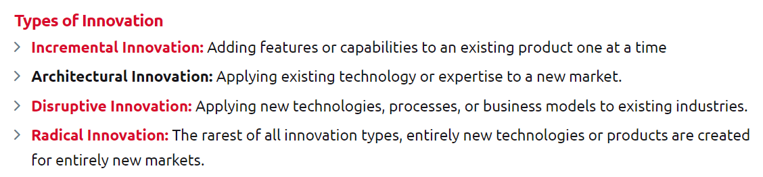
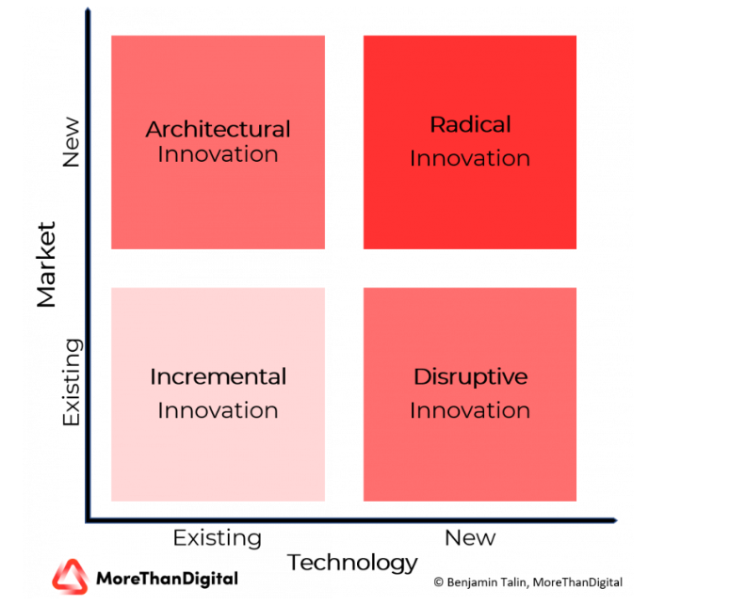

What is Design Thinking?
Design thinking is a non-linear, iterative process that teams use to understand users, challenge assumptions, redefine problems and create innovative solutions to prototype and test. Involving five phases—Empathize, Define, Ideate, Prototype and Test—it is most useful to tackle problems that are ill-defined or unknown.
Design thinking is a human-centered approach to innovation—anchored in understanding customer’s needs, rapid prototyping, and generating creative ideas—that will transform the way you develop products, services, processes, and organizations.

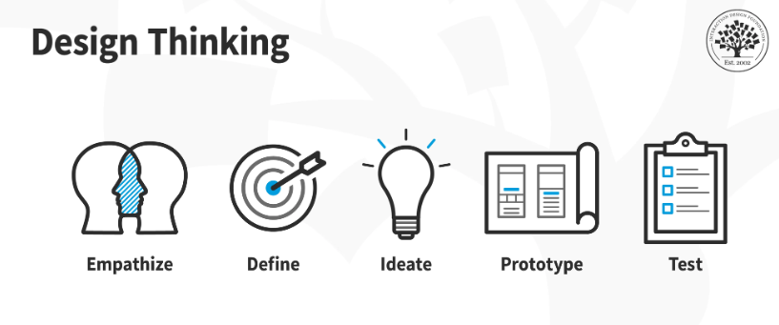

Why Is Design Thinking so Important?
In user experience (UX) design, it’s crucial to develop and refine skills to understand and address rapid changes in users’ environments and behaviors. The world has become increasingly interconnected and complex since cognitive scientist and Nobel Prize laureate Herbert A. Simon first mentioned design thinking in his 1969 book, The Sciences of the Artificial, and then contributed many ideas to its principles. Professionals from a variety of fields, including architecture and engineering, subsequently advanced this highly creative process to address human needs in the modern age. Twenty-first-century organizations from a wide range of industries find design thinking a valuable means to problem-solve for the users of their products and services. Design teams use design thinking to tackle ill-defined/unknown problems (aka wicked problems) because they can reframe these in human-centric ways and focus on what’s most important for users. Of all design processes, design thinking is almost certainly the best for “thinking outside the box”. With it, teams can do better UX research, prototyping and usability testing to uncover new ways to meet users’ needs.
Design thinking’s value as a world-improving, driving force in business (global heavyweights such as Google, Apple and Airbnb have wielded it to notable effect) matches its status as a popular subject at leading international universities. With design thinking, teams have the freedom to generate ground-breaking solutions. Using it, your team can get behind hard-to-access insights and apply a collection of hands-on methods to help find innovative answers.
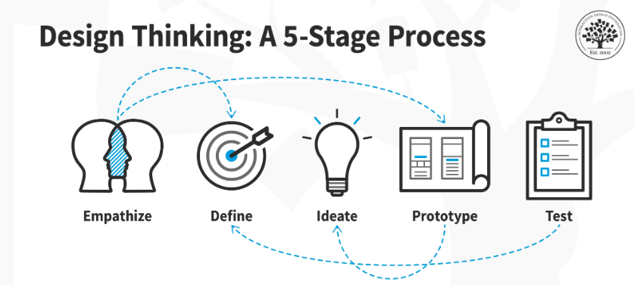
Design thinking is an iterative and non-linear process that contains five phases: 1. Empathize, 2. Define, 3. Ideate, 4. Prototype and 5. Test.
- Stage 1: Empathize—Research Your Users' Needs
Here, you should gain an empathetic understanding of the problem you’re trying to solve, typically through user research. Empathy is crucial to a human-centered design process such as design thinking because it allows you to set aside your own assumptions about the world and gain real insight into users and their needs.
- Stage 2: Define—State Your Users' Needs and Problems
It’s time to accumulate the information gathered during the Empathize stage. You then analyze your observations and synthesize them to define the core problems you and your team have identified. These definitions are called problem statements. You can create personas to help keep your efforts human-centered before proceeding to ideation.
- Stage 3: Ideate—Challenge Assumptions and Create Ideas
Now, you’re ready to generate ideas. The solid background of knowledge from the first two phases means you can start to “think outside the box”, look for alternative ways to view the problem and identify innovative solutions to the problem statement you’ve created. Brainstorming is particularly useful here..
- Stage 4: Prototype—Start to Create Solutions
This is an experimental phase. The aim is to identify the best possible solution for each problem found. Your team should produce some inexpensive, scaled-down versions of the product (or specific features found within the product) to investigate the ideas you’ve generated. This could involve simply paper prototyping.
- Stage 5: Test—Try Your Solutions Out
Evaluators rigorously test the prototypes. Although this is the final phase, design thinking is iterative: Teams often use the results to redefine one or more further problems. So, you can return to previous stages to make further iterations, alterations and refinements – to find or rule out alternative solutions.

What is a prototype?
A product prototype is a simulation designed to test a product's UX&UI concept and core functionality. It’s a way to represent and demonstrate software’s fundamental design and function without being fully functional.
Companies create prototypes to find user flows and design mistakes before building a final product. Prototypes can come in various shapes and sizes. It can be a paper prototype, a sketch or even a fully functional interactive version. Also, the level of usability and detail of a prototype can vary – usually, it’s a demonstration of what the product will look like.

A prototype is a way to rapidly test the basic ideas and assumptions behind the product.

Benefits of prototyping
Building a prototype allows businesses to acquaint themselves early with the way users will interact with the product in the future. It’s also effective in stimulating new ideas about the product. Here are the most important advantages of a prototype:
- Prototyping is cost- and time-effective. Potential issues are found and fixed early.
- It’s beneficial for the development team – they can better understand what is expected of the software and its specifications. It’s a way to save money in the long run as you can see the flaws that should be removed before the development work starts.
- A prototype is a great way to see what the business vision will look like as a functioning product, beyond a conceptual idea or diagrams on a piece of paper.
- It ensures the product can be greatly improved and more closely match the requirements of users.
- UX validation – creating a prototype is one of the most effective ways to validate the product’s UX and usability. See how UX prototype can improve your product.

What is MVP development?
MVP stands for minimum viable product. It’s the simplest version of your software product that can be released publicly to gain feedback from your users. The minimum viable product focuses only on the core functionality. It has enough features to attract early adopters and validate the product idea at an early stage of the product development process. Companies release a minimum viable product to:
- Launch the product on the market as soon as possible.
- Validate new ideas with real users before spending too much of the budget.
- Collect user feedback – you can easily find out what early users think about your software.
- Save resources and money – you don’t have to implement all the features into your . minimum viable product. Thus, the development work is reduced.
- Attract investors – an MVP can help you attract more investment by demonstrating the product’s appeal and gathering user feedback.
So, with every iteration of your minimum viable product, you know more about users’ problems and can further refine your solution.

An MVP is a usable version of the product with just the core feature or features, ideal for testing, resulting in feedback and useful data, yet with a minimum of time and money invested at this stage.

Examples of an MVP
- example is Facebook. Upon release, it was a basic social media tool created to connect with friends. The idea turned out to be worth expanding. The platform gradually added more and more complex features.
- Spotify

Benefits of an MVP
A minimum viable product provides instant value while minimizing development costs and reveals the most suitable direction for further development. The most important benefits of an MVP are:
- It allows you to test your business concept – you only offer the core features rather than testing your key hypotheses with feature-heavy software. At the same time, you conduct user testing and keep costs down.
- You save money – iterative creation of apps spreads your costs over time.
- It’s a great way for your product to evolve – you can start creating a user base to gain insight into what works and what doesn’t. Thanks to such information, you can make decisions on future iterations of the product.

What is the difference between a prototype and an MVP?
- A prototype tests the idea. An MVP tests the product.
- A prototype tests the basic concept; an MVP tests features, treating the basic concept as already proven.
- An MVP is functional, it can be used (in however limited a way). A prototype is often more like the visual appearance of the product.
- A prototype can be a foundation for the MVP design (in some cases, it makes sense

So, which should you use: Prototype or MVP?
If you need to test the basic product concept and you’re working within a very limited budget, create a prototype.
If you want to compare a feature’s performance against what users really want, build an MVP.
-------------------------------------------------------------------------------------------
TOOLS OF DESIGN THINKIG
- Visualization is about using images. It’s not about drawing; it’s about visual thinking. It pushes us beyond using words or language alone. It is a way of unlocking a different part of our brains that allows us to think nonverbally and that managers might not normally use.
When you explain an idea using words, the rest of us will form our own mental pictures, usually informed by our training. When you say, “We need a new growth platform,” the IT specialist sees servers and code and the marketing guru sees an advertising campaign. If instead you present your idea to us by drawing a picture of it, you reduce the possibility of unmatched mental models.
- Journey mapping (or experience mapping) is an ethnographic research method that focuses on tracing the customer’s “journey” as he or she interacts with an organization while in the process of receiving a service, with special attention to emotional highs and lows. Experience mapping is used with the objective of identifying needs that customers are often unable to articulate.
It’s done by laying out a hypothetical view of what a certain customer group’s journey looks like, even the part that doesn’t include your firm. Then conduct pilot interviews with a small number of customers to be sure you’re accurately capturing the steps. Finally, identify essential moments of truth and themes from the interviews and identify a number of dimensions that you believe to be useful in understanding the differences in the data you have gathered. The purpose is to produce a set of hypotheses for testing.
- Value chain analysis examines how an organization interacts with value chain partners to produce, market and distribute new offerings. Analysis of the value chain offers ways to create better value for customers along the chain and uncovers important clues about partners’ capabilities and intentions.
Value chain analysis is the business-side equivalent of customer journey mapping. It begins by working backward from value creation for the ultimate end customer and then adding the capabilities and bargaining power of other key suppliers.
- Mind mapping is used to represent how ideas or other items are linked to a central idea and to each other. Mind maps are used to generate, visualize, structure and classify ideas to look for patterns and insights that provide key design criteria. We do this by displaying the data and asking people to cluster them in ways that allow themes and patterns to emerge. To succeed, mind mapping must be a team sport.
Tap into the power of visualization to communicate the key components of what we have learned and display them as clearly and simply as possible. Create posters that capture key themes and trends in the data, then invite a group of thoughtful people to tour the visual data and note any learnings that they believe should inform new ideas, then cluster those learnings into themes. Look for connections between clusters and insights. Pose the question, “Based on what we have learned, if anything were possible, what attributes would our design have?”
- Rapid concept development assists us in generating hypotheses about potential new business opportunities.
In the first stage, we take the design criteria, the customer personas and their pain points and the value chain insights we have unearthed in our research and use all of it to generate new ideas — lots of them. In the second stage, we assemble the ideas into a manageable number of interesting concepts. Finally, in stage three, we elaborate on the business design behind that handful of concepts. We want to generate ideas quickly and get them out to customers to have a look at them as soon as possible.
- Assumption testing focuses on identifying assumptions underlying the attractiveness of a new business idea and using available data to assess the likelihood that these assumptions will turn out to be true. These assumptions are then tested through thought experiments, followed by field experiments.
Once you have determined which assumptions are most critical to the potential attractiveness of your new concept, identify the data that allows you to conclusively test key assumptions. Here, we are identifying the information we need and then figuring out how to get it.
Sort the data you need into one of the following three categories: what you know, what you don’t know and can’t know, and what you don’t know but could. The third category is pay dirt for the creation of thought experiments. Identify what it would take to get the data quickly, then design your thought experiment, paying special attention to the data that could prove you wrong.
- Rapid prototyping techniques allow us to make abstract new ideas tangible to potential partners and customers. These include storyboarding, user scenarios, experience journeys and business concept illustrations — all of which encourage deep involvement by important stakeholders to provide feedback.
Prototyping is all about minimizing the “I” in ROI. The cost of a simple 2-D prototype could be as low as a pen and some paper. Business concept prototypes generally take visual and narrative forms: images and stories. They can even include role-playing and skits. Play with your prototype; don’t defend it. Let others validate it — not the people who created it.
- Customer co-creation incorporates techniques that allow managers to engage a customer while in the process of generating and developing new business ideas of mutual interest. They are among the most value-enhancing, risk-reducing approaches to growth and innovation.
In our Six Sigma world, which values perfection and polish, we tend to get anxious about showing customers unfinished, unpolished “stuff.” Get over it. Innovation is about the learning, and customers have the most to teach us. The sooner we get something in front of them that they can react to, the faster we will get to a differentiated value-added solution.
Engage a diverse and candid group of customers one at a time. Provide them with visual stimulus, but nothing fancy at this stage. Leaving parts of the concept incomplete is a great way to elicit the customers’ creativity and competence. Offer two or three options and begin exploring one they are drawn to.
- Learning launches are designed to test the key underlying value-generating assumptions of a potential new-growth initiative in the marketplace. In contrast to a full new-product rollout, a learning launch is a learning experiment conducted quickly and inexpensively to gather market-driven data.
We call them launches, rather than experiments, because they are meant to feel real to both launchers and customers. Only then can they yield reliable data. They are an extension of the co-creation process, but at this stage, we are asking customers to put their money where their mouths are. People who say they will buy remain only potential customers. The only true test of the value of an idea for customers is their willingness to part with cold hard cash. (For more on learning launches, please see “The Learning Launch: How to Grow Your Business With the Scientific Method.”)
- Storytelling is exactly how it sounds: weaving together a story rather than just making a series of points. It is a close relative of visualization — another way to make new ideas feel real and compelling. Visual storytelling is actually the most compelling type of story. All good presentations — whether analytical or design-oriented — tell a persuasive story.
Like images, stories allow us to access emotions and emphasize experiences. They add the richness of context and allow us to “sell” a problem as well as its solution. With any luck, they keep their audiences awake.
Good stories follow some basic principles: Be sure to identify your audience. It is critical to create a storyboard; it allows us to pay careful attention to flow and logic. Set the scene to sell the problem, make your cast of characters feel real and work the plot; all good stories unfold with some tension, and maybe some surprises develop — here is where you think about how to combine data and pictures to drive home your points. For the climax, unveil your resolution to the problem. Make it compelling. And don’t forget the use of metaphors and analogies to bring your story to life!

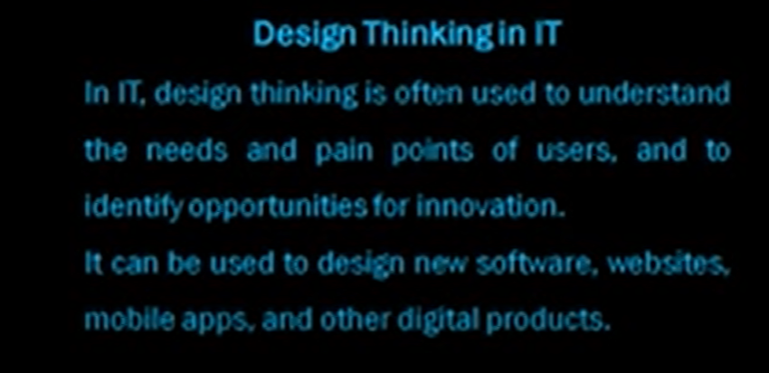

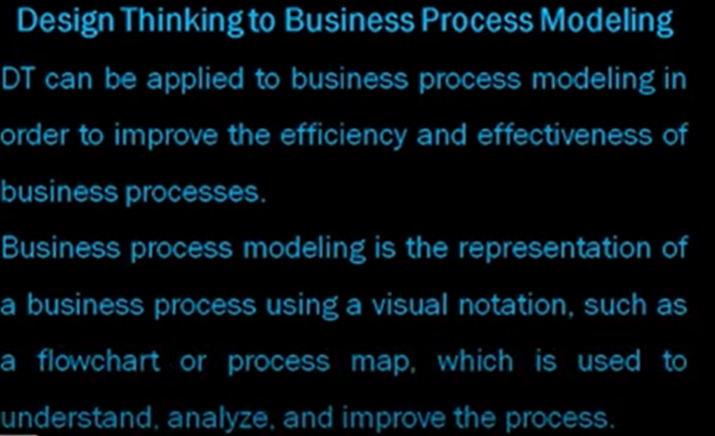

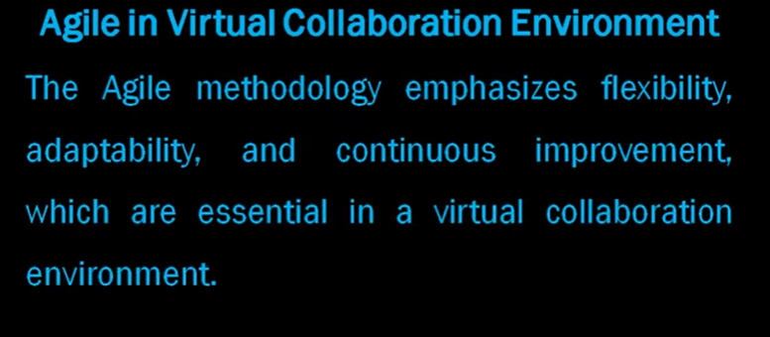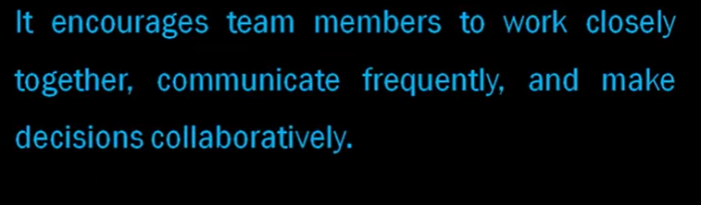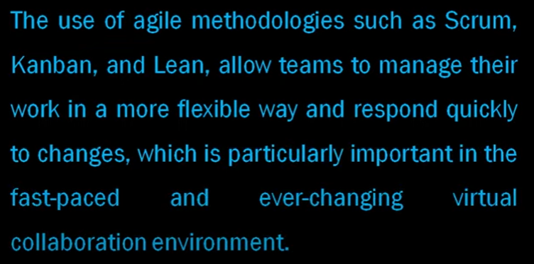

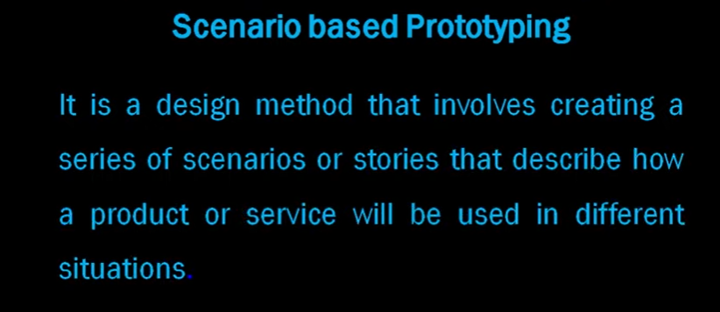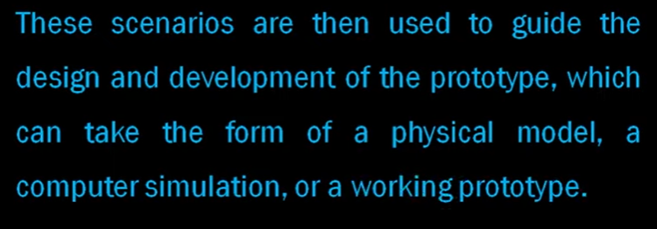

Business process modeling gives organizations a simple way to understand and optimize workflows by creating data-driven visual representations of key business processes.

What is business process modeling?
A business process model is a graphical representation of a business process or workflow and its related sub-processes. Process modeling generates comprehensive, quantitative activity diagrams and flowcharts containing critical insights into the functioning of a given process, including the following:
- Events and activities that occur within a workflow
- Who owns or initiates those events and activities
- Decision points and the different paths workflows can take based on their outcomes
- Devices involved in the process
- Timelines of the overall process and each step in the process
- Success and failure rates of the process

Components of a business process model
Though every business process is different, there are some common elements that you will find in most models. The following are the four main components of business process models.
- The sequence of activities: This is the order in which the activities will be carried out.
- The people or roles involved: This component includes anyone who will be carrying out the activities.
- The resources required: These are anything needed to carry out the activities, such as materials, equipment, or information.
- The outputs of each activity: This component includes anything produced as a result of the activity, such as a document, product, or service.

There are many benefits to business process modeling:
- Gives everyone a clear understanding of how the process works
- Provides consistency and controls the process
- Identifies and eliminates redundancies and inefficiencies
- Sets a clear starting and ending to the process
Business process modeling can also help you group similar processes together and anticipate how they should operate. The primary objective of business process modeling tools is to analyze how things are right now and simulate how should they be carried out to achieve better results.

Business process modeling techniques
There are several different techniques that you can use when creating a business process model. The most common techniques include:
- Role interaction diagrams: Role interaction diagrams show the interactions between different roles in a process. Two common types of role interaction diagrams are sequence and collaboration diagrams. Sequence diagrams show the order in which activities are carried out. They can be used to identify what is needed for specific business activities. On the other hand, collaboration diagrams show how different roles interact with each other. They can be used to visualize the responsibilities of each role and identify areas where there is potential for confusion or misunderstanding.
- Flowcharts: Flowcharts are one of the most commonly used business process modeling techniques. They provide a high-level overview of a process flow and can be used to identify both simple and complex processes. When creating a flowchart, you need to use symbols to represent different activities, decision points, and connectors.
- Gantt Charts: Gantt charts are a type of bar chart that is often used in project management. They can be used to visualize the sequence of activities in a process and track a project's progress. Gantt charts can also identify potential risks and issues and make sure that they are addressed promptly.
- Data flow diagrams: Data flow diagrams show the movement of data through a process. They can be used to identify where data enters and leaves the system and how it is transformed along the way. Data flow diagrams use symbols to represent different activities, data stores, and data flows.
- BPMN: BPMN is a standard business process modeling notation. It includes graphical representation with symbols representing flow objects, connecting objects, swim lanes, and artifacts. With BPMN diagrams, you can create standardized models that all team members can easily understand.
- EPC: EPC is a modeling notation based on event-driven process chains. It uses symbols to represent different events, functions, and connectors. EPC diagrams can be used to create autonomous business processes that software can execute.
- UML activity diagrams: Unified modeling language (UML) activity diagrams are essential for illustrating the design of a system in a way that is understandable to all stakeholders, business analysts, and people without programming knowledge. They can be used to show the flow of data and control between different parts of a system.
- Object-oriented methods: Object-oriented methods are a type of business process modeling based on objects and classes. With this technique, you can create more detailed and complex models. Object-oriented methods use encapsulation, inheritance, and polymorphism to develop models.
- Role activity diagrams: Role activity diagrams can be used to illustrate intangible activities within an organization. They can be used to show how different roles interact with each other and how they contribute to the organization's overall goal. Role activity diagrams are helpful in understanding the relationships between different parts of an organization.

What is agile?
Agile methodology was first used by software developers, who recognised the value in "individuals and interactions over processes and tools" and "customer collaboration over contract negotiation." Now, agile working is a productive and popular project management technique. Seventy-one percent of organisations are using agile approaches in their projects.
It’s all about streamlining processes and bringing multi-disciplinary teams together, outside of traditional hierarchies. Breaking down silos and empowering employees opens up new levels of efficiency, which organisations can measure through performance and results.
In agile, teams split work into sprints – short periods attached to specific, small goals. Each sprint contributes to the overall deliverable of the project.
There are four stages of a sprint:
- Plan
- Develop
- Deploy
- Evaluate
Teams work collaboratively to the sprint deadline, with the relevant people working together on a specific task. With each sprint working efficiently and effectively, the overall project is more likely to be delivered on time, to a high standard. What teams learn from each sprint is evaluated and taken into the next one, so the project can evolve to cope with challenges along the way.
Agile is a new take on reaching project goals. While traditional methods use a linear approach that follows a rigid sequence of steps, agile working emphasises collaboration and flexibility, reviewing and incorporating feedback rather than making a plan upfront and sticking with it.
Putting flexibility at the centre of projects makes agile an ideal way of working as organisations adapt to new hybrid and remote working models. It’s challenging to plan in a continually changing environment, so adapting to circumstances is essential. With remote and hybrid working now an established part of the landscape, agile projects are better at promoting collaboration with minimum disruption.

Scenario based prototyping
The three major facets of software requirements engineering are: (1) requirements identification, (2) requirements analysis, and (3) requirements communication. Much research addresses the latter two aspects, but few practical approaches exist for addressing the first one. Hence, system requirements remain the most critical and problem prone area of system development. There is thus an urgent need for a methodology which helps a user identify requirements and realize potential impacts, in a timely manner. The objectives of this research are: (1) develop a methodology (and accompanying tools) to aid users in identifying requirements before building a system, and (2) evaluate the effectiveness of the methodology (and tools) in actual use. The novel approach of this research is an attempt to capture the conceptual system as visualized by the user, by use of operational examples ("scenarios"). By means of simulation and man-machine interface techniques, the scenarios may serve as a "quick and dirty" prototype of the intended system, providing the means for requirements analysis and validation, and for communicating the real intent of the requirements. It is anticipated that the methodology can be extended to fully support the concept of step-wise refinement and continuing system validation.

Scenario-based prototyping is an approach for designing complex software systems that is based on models, both structural and behavioral models. The approach supports the stepwise and interactive enrichment of the prototype model, the traceability between the artifacts collected during earlier design phases, and the validation of the prototype with end-users ¹.
Some benefits of scenario-based prototyping include:
- Gain first-hand insights into how users will interact with the product.
- Identify any usability issues or design flaws before it’s too late.
- Focus on the users’ goals, their problems, and their context, without providing any solutions.
- Explore situations within the system that you’re targeting physically.
- Capture and enact the user’s experience of using a product or service.
- Create scenario maps to explore ideas with your team and with users.

Some limitations of scenario-based prototyping include:
- Costly with respect to time as well as money.
- There may be too much variation in requirements each time the prototype is evaluated by the customer.
- Poor documentation due to continuously changing customer requirements ¹

To evaluate the effectiveness of a prototype, you can follow these steps ¹:
- Confirm the Prototype
- Develop Questions
- Design Methods
- Test & Adapt
- Make Decisions

Question Paper links
- https://www.toprankers.com/design-thinking-awareness-questions-and-answers

- https://www.teachmint.com/tfile/studymaterial/isem-asection/2idt19innovdesignthink/21idt1929mcqs/d4e7f10f-94d5-4f9b-a36a-d2bb5a634743

- https://www.atnyla.com/general-knowledge/112/395

- https://quizizz.com/admin/quiz/5da5dd67c0008c001d4813d3/design-thinking

